Computer Programming  
Lab Tasks



Department of Computer Science - BUIC

Name: Saad Ahmad

Enrollment Number: 01-134222-130

**Exercises/Lab Journal1**

1. Suppose you had an appointment with a doctor at one week’s time but due to some important task you want to change an already booked doctor’s appointment on phone, draw a flow chart using draw.io online tool. Use appropriate notations for flow chart as we practiced in lab 1.

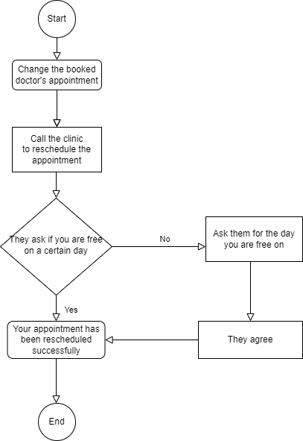

2. Write the program using endl manipulator to display the following text:

**C++**

**programming is not**

**that though**

**Code:**

#include <iostream>

int main()

{

std::cout << "\t C++" << std::endl;

std::cout << "\tprogramming is not" << std::endl;

std::cout << "\t that tough" << std::endl;

return 0;

}

**Output:**

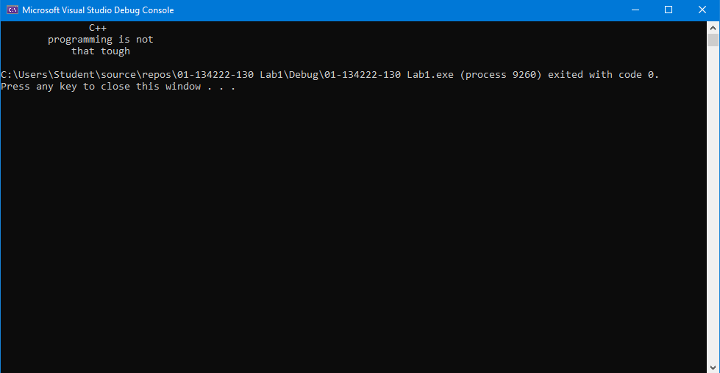

3. Write a program yourself using **escape sequences** to print the following triangle on screen



**Code:**

#include <iostream>

int main()

{

std::cout << "\t /\\ \n\t / \\ \n\t / \\ \n \t / \\\n\t --------";

return 0;

}

**Output:**

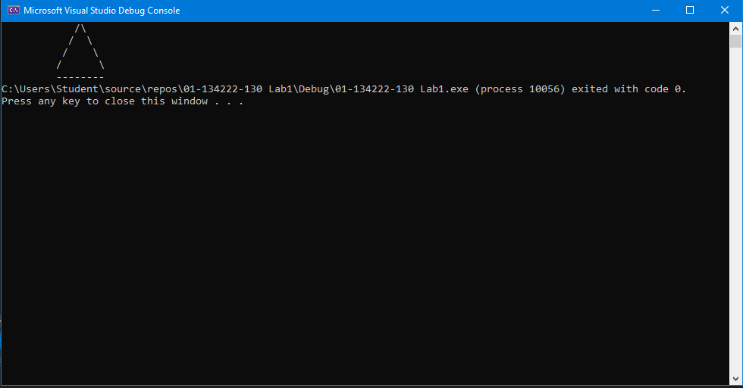

4. Write a program yourself using **escape sequences** to print the following rectangle on screen

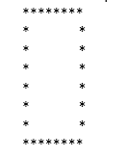

**Code:**

#include <iostream>

int main()

{

std::cout << "\t********\n";

std::cout << "\t* *\n";

std::cout << "\t* *\n";

std::cout << "\t* *\n";

std::cout << "\t* *\n";

std::cout << "\t* *\n";

std::cout << "\t* *\n";

std::cout << "\t********\n";

return 0;

}

**Output:**

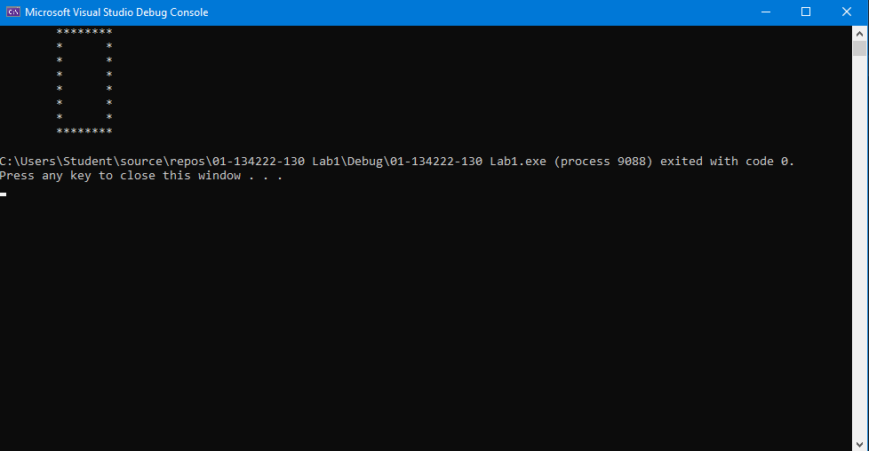

1. Write a program yourself using **escape sequences** to print the following square on screen

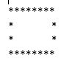

**Code:**

#include <iostream>

int main()

{

std::cout << "\t********\n";

std::cout << "\t* *\n";

std::cout << "\t* *\n";

std::cout << "\t********\n";

return 0;

}

**Output:**

